- Register Jyotish
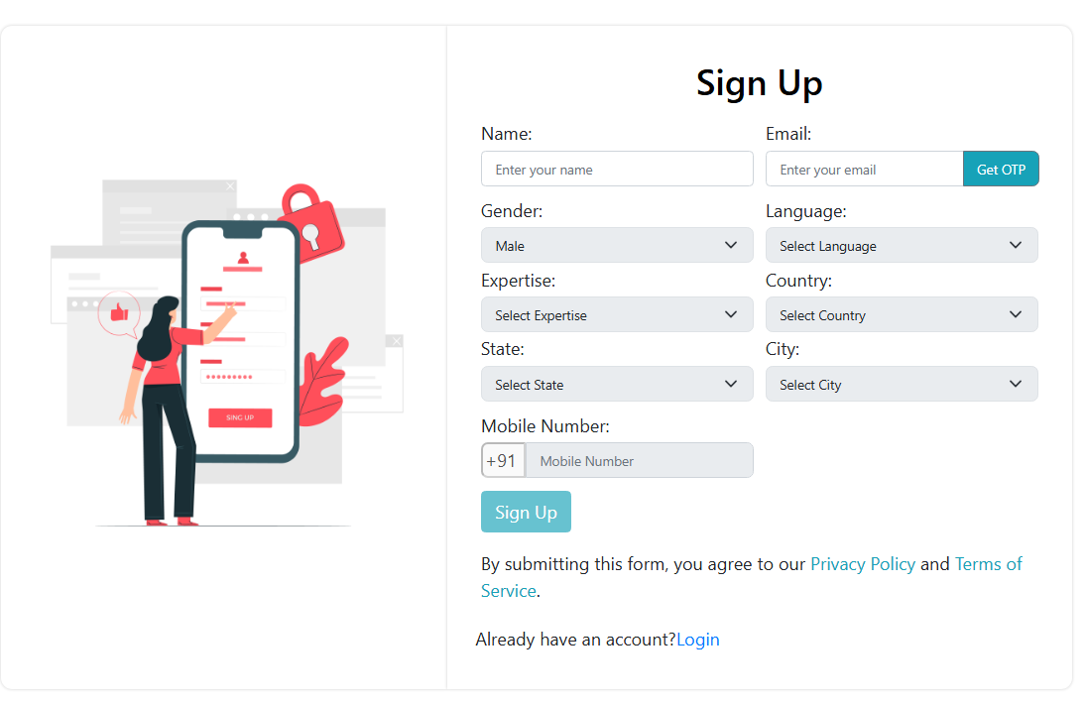

Api List -> BaseUrl=”https://api.myjyotishg.in/”
1. Api/Account/RegisterJyotish –(sendOtp)
Parameter -email (string)
- Api/Account/VerifyJyotish –(verify Otp)
Parameter -Email-(string)
Otp-(int)
- Api/Account/Languages
- Api/Jyotish/Expertise
- Api/Jyotish/Country
- Api/Jyotish/State
Parameter –Id –(int)-(countryId)
- Api/Jyotish/City
Parameter – Id-(int)-(stateId)
- Api/Jyotish/countryCode
Parameter – country –(int)-(countryId)
- Api/Account/SignUpJyotish
- Parameter –(formData)
Name –(string)
Email – (string)
Gender-(string)
Mobile – (int)
Language –(string)
Expertise- (string)
Country-(int)
State-(int)
City-(int)
DateOfBirth-(date)

